**Deep Learning Fundus Image Analysis For Early Detection Of Diabetic Retinopathy**

# INTRODUCTION

* 1. Overview

Diabetic retinopathy stands as a significant global health concern, especially given its status as a leading cause of blindness among working-age adults. The prevalence of diabetes mellitus continues to rise worldwide, amplifying the risk of diabetic retinopathy and its associated complications. Uncontrolled diabetes damages the blood vessels in the retina, leading to vision impairment and, if left untreated, eventual blindness. This condition not only affects the individual's quality of life but also poses substantial socioeconomic burdens on healthcare systems. Early detection and intervention are pivotal in mitigating the progression of diabetic retinopathy, making it imperative to address this escalating concern through effective screening strategies and advanced technological solutions.

* 1. Purpose

The purpose of the system described in the project report on "Deep Learning Fundus Image Analysis for Early Detection of Diabetic Retinopathy" is to leverage deep learning techniques to develop an automated and accurate method for detecting diabetic retinopathy from fundus images. Fundus imaging is a critical tool in diagnosing this condition, but manual interpretation can be time-consuming and subjective. By employing deep learning algorithms, the system aims to enhance the efficiency and accuracy of diabetic retinopathy diagnosis, enabling early detection and intervention. Ultimately, the system's goal is to contribute to better patient outcomes by enabling timely treatment and reducing the risk of vision loss associated with diabetic retinopathy.

Fundus imaging plays a pivotal role in the diagnosis and management of diabetic retinopathy (DR). This non-invasive imaging technique captures high-resolution images of the retina, allowing clinicians to visualize the delicate blood vessels and assess for characteristic changes indicative of DR, such as microaneurysms, hemorrhages, and neovascularization. The detailed images obtained through fundus photography or scanning enable early detection and monitoring of the progression of DR, facilitating timely intervention to prevent vision loss. However, the manual analysis of these images is labor-intensive, time-consuming, and prone to subjectivity, leading to variability in interpretations among healthcare professionals. Hence, there is a pressing need for automated analysis methods, such as those based on deep learning algorithms, to streamline the evaluation process, improve diagnostic accuracy, and enable scalable screening programs. Automated systems have the potential to analyze fundus images swiftly, consistently, and objectively, assisting clinicians in early detection and intervention, thereby enhancing the effectiveness of DR management strategies.

# LITERATURE SURVEY

* 1. Existing problem

Research Paper 1:

Title: "Automated detection of diabetic retinopathy using deep learning"

Authors: Gulshan V, Peng L, Coram M, et al. (Published in JAMA in 2016)

Summary: This study utilized a deep learning algorithm to analyze a dataset of fundus images for the detection of diabetic retinopathy. The research demonstrated the efficacy of deep learning methods in accurately identifying diabetic retinopathy and diabetic macular edema, showing substantial agreement with expert ophthalmologist evaluations. The findings underscored the potential for automated analysis methods to aid in the early detection and management of diabetic retinopathy, especially in areas with limited access to eye care specialists.

Research Paper 2:

Title: "Automated grading system for detection of diabetic retinopathy using fundus images"

Authors: Rajalakshmi R, Subashini R, Anjana RM, Mohan V (Published in Journal of Medical Systems in 2017)

Summary: This research paper presented an automated grading system employing machine learning techniques for diabetic retinopathy detection using fundus images. The study demonstrated the system's ability to accurately classify retinal images into different severity levels of diabetic retinopathy, providing a reliable assessment comparable to manual grading by ophthalmologists. The paper emphasized the importance of automated systems in facilitating early detection and timely intervention, particularly in resource-limited settings where access to specialized eye care is limited.

These papers support the importance of fundus imaging in diabetic retinopathy diagnosis and highlight the potential of automated analysis methods, particularly those based on deep learning and machine learning algorithms, in improving accuracy and accessibility to early detection and management of diabetic retinopathy.

* 1. Proposed solution

Transfer learning has become one of the most common techniques that has achieved better performance in many areas, especially in medical image analysis and classification. We used Transfer Learning techniques like Inception V3,Resnet50,Xception V3 that are more widely used as a transfer learning method in medical image analysis and they are highly effective.

# THEORITICAL ANALYSIS

* 1. Block diagram

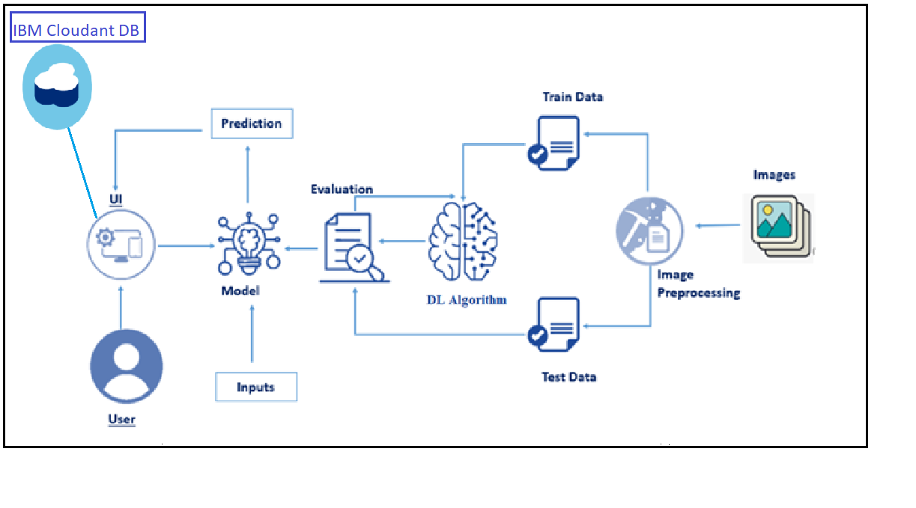

* 1. Hardware / Software designing

Hardware and software requirements of the project

# EXPERIMENTAL INVESTIGATIONS

Analysis or the investigation made while working on the solution.

# FLOWCHART

Diagram showing the control flow of the solution

# RESULT

Final findings (Output) of the project along with screenshots.

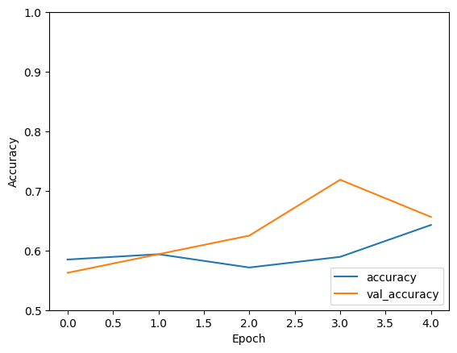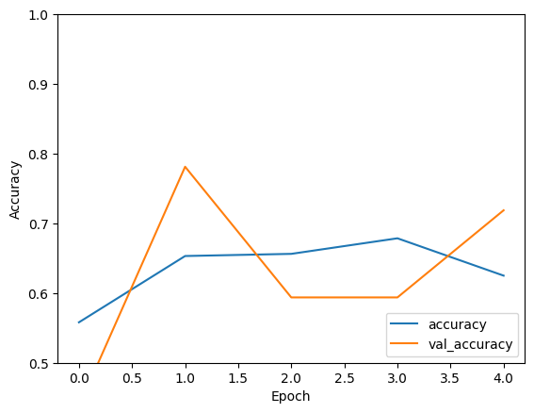

# ADVANTAGES & DISADVANTAGES

List of advantages and disadvantages of the proposed solution

# APPLICATIONS

The areas where this solution can be applied

# CONCLUSION

Conclusion summarizing the entire work and findings.

# FUTURE SCOPE

Enhancements that can be made in the future.

# BIBILOGRAPHY

References of previous works or websites visited/books referred for analysis about the project, solution previous findings etc.

Oh, K., Kang, H. M., Leem, D., Lee, H., Seo, K. Y., & Yoon, S. (2021). Early detection of diabetic retinopathy based on deep learning and ultra-wide-field fundus images. *Scientific reports*, *11*(1), 1897.

Yalçin, N., Alver, S., & Uluhatun, N. (2018, May). Classification of retinal images with deep learning for early detection of diabetic retinopathy disease. In *2018 26th Signal Processing and Communications Applications Conference (SIU)* (pp. 1-4). IEEE.

# APPENDIX

A. Source Code

Attach the code for the solution built.

**Note: Limit the report to 15 pages.**